Process of data import into MySQL workbench:

The following tables were imported into R as R dataframe objects using the following code

***con <- dbConnect(SQLite(),'FPA_FOD_20170508.sqlite')***

***dbListTables(con)***

***fires <- dbReadTable(con,'Fires')***

1. Fires
2. geometry_columns_statistics
3. geometry_columns_time
4. idx_fires_shape_rowid
5. idx_fires_shape_parent
6. idx_fires_shape_node
7. idx_fires_shape
8. geometry_columns_statistics
9. geometry_columns_auth
10. geometry_columns
11. geom_cols_ref_sys
12. geometry_columns_statistics
13. geometry_columns_time
14. idx_fires_shape
15. idx_fires_shape_node
16. idx_fires_shape_parent
17. idx_fires_shape_rowid
18. NWCG_UnitIDActive_20170109
19. spatialite_history
20. spatial_ref_sys_aux
21. spatial_ref_sys_all
22. spatial_ref_sys
23. sqlite_sequence
24. vector_layers
25. vector_layers_auth
26. vector_layers_statistics

**Data loaded into R dataframes:**

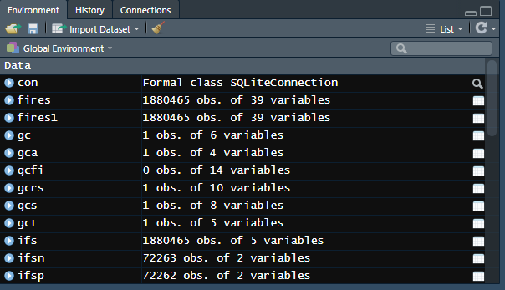

**Null values for each table: (Sparse data)**

|  |  |  |
| --- | --- | --- |
| **Fires** | | |
| **Column Name** | **Count** | **Percentage** |
| OBJECTID | 0 | 0.00 |
| FOD_ID | 0 | 0.00 |
| FPA_ID | 0 | 0.00 |
| SOURCE_SYSTEM_TYPE | 0 | 0.00 |
| SOURCE_SYSTEM | 0 | 0.00 |
| NWCG_REPORTING_AGENCY | 0 | 0.00 |
| NWCG_REPORTING_UNIT_ID | 0 | 0.00 |
| NWCG_REPORTING_UNIT_NAME | 0 | 0.00 |
| SOURCE_REPORTING_UNIT | 0 | 0.00 |
| SOURCE_REPORTING_UNIT_NAME | 0 | 0.00 |
| LOCAL_FIRE_REPORT_ID | 1459286 | 77.60 |
| LOCAL_INCIDENT_ID | 820821 | 43.65 |
| FIRE_CODE | 1555636 | 82.73 |
| FIRE_NAME | 957189 | 50.90 |
| ICS_209_INCIDENT_NUMBER | 1854748 | 98.63 |
| ICS_209_NAME | 1854748 | 98.63 |
| MTBS_ID | 1869462 | 99.41 |
| MTBS_FIRE_NAME | 1869462 | 99.41 |
| COMPLEX_NAME | 1875282 | 99.72 |
| FIRE_YEAR | 0 | 0.00 |
| DISCOVERY_DATE | 0 | 0.00 |
| DISCOVERY_DOY | 0 | 0.00 |
| DISCOVERY_TIME | 882638 | 46.94 |
| STAT_CAUSE_CODE | 0 | 0.00 |
| STAT_CAUSE_DESCR | 0 | 0.00 |
| CONT_DATE | 891531 | 47.41 |
| CONT_DOY | 891531 | 47.41 |
| CONT_TIME | 972173 | 51.70 |
| FIRE_SIZE | 0 | 0.00 |
| FIRE_SIZE_CLASS | 0 | 0.00 |
| LATITUDE | 0 | 0.00 |
| LONGITUDE | 0 | 0.00 |
| OWNER_CODE | 0 | 0.00 |
| OWNER_DESCR | 0 | 0.00 |
| STATE | 0 | 0.00 |
| COUNTY | 678148 | 36.06 |
| FIPS_CODE | 678148 | 36.06 |
| FIPS_NAME | 678148 | 36.06 |
| Shape | 0 | 0.00 |

|  |  |  |
| --- | --- | --- |
| **NWCG_UnitIDActive_20170109** | | |
| **Column Name** | **Count** | **Percentage** |
| OBJECTID | 0 | 0.00 |
| UnitId | 0 | 0.00 |
| GeographicArea | 0 | 0.00 |
| Gacc | 0 | 0.00 |
| WildlandRole | 0 | 0.00 |
| UnitType | 0 | 0.00 |
| Department | 350 | 5.97 |
| Agency | 398 | 6.78 |
| Parent | 5867 | 100.00 |
| Country | 0 | 0.00 |
| State | 0 | 0.00 |
| Code | 0 | 0.00 |
| Name | 0 | 0.00 |

|  |  |  |
| --- | --- | --- |
| **idx_fires_shape** | | |
| **Column Name** | **Count** | **Percentage** |
| Pkid | 0 | 0 |
| Xmin | 0 | 0 |
| Xmax | 0 | 0 |
| Ymin | 0 | 0 |
| Ymax | 0 | 0 |

**Problems with data loading:**

**Buffer pool size:**

Increasing the buffer_pool_size in my.ini file from 8MB to 1024MB solved the problem of

***Error Code: 1206. The total number of locks exceeds the lock table size***

**Bad Data:**

There were problems with inserting data into MySQL as the original dataset contained characters that did not comply with the utf8mb4 charset of MySQL





The dataset was then exported to a text file and the following python script was run to identify ASCII characters beyond 126

***with open("C:/Users/Varun/Desktop/MSBA/DB/Assignment 5/my_data_old.txt") as f:***

***while True:***

***c = ord(f.read(1))***

***if not c:***

***print("End of file")***

***break***

***elif(c>126):***

***print(c)***

The following characters were identified.

|  |
| --- |
| **ASCII** |
| 160 |
| 176 |
| 191 |
| 192 |
| 198 |
| 201 |
| 209 |
| 241 |

Two options were considered:

1. Changing the charset from utf8mb4 to latin1 as that would allow characters like À and É
2. Replacing all occurrences of the problematic characters with other characters

Option 1 did not work.

Option 2 was followed.

The following R code was used to replace all occurrences of problematic ASCII values with its replacement

***fires1$COMPLEX_NAME <- gsub("\u00C0", "A", fires1$COMPLEX_NAME, fixed = TRUE)***

The transformation was applied to all the columns for each and every problematic character.

**For fires table:**

|  |  |  |  |
| --- | --- | --- | --- |
| **ASCII Value** | **Character** | **Encoding** | **Replacement** |
| 160 |  | \u00A0 |  |
| 176 | ° | \u00B0 | * |
| 191 | ¿ | \u00BF | ' |
| 192 | À | \u00C0 | A |
| 198 | Æ | \u00C6 | AE |
| 201 | É | \u00C9 | E |
| 209 | Ñ | \u00D1 | N |
| 241 | ñ | \u00F1 | N |

ASCII value 160, which is a non breaking space has been replaced with a regular space.

|  |  |  |  |
| --- | --- | --- | --- |
| **ASCII Value** | **OBJECTID** | **Before** | **After** |
| 160 | 2752 | BROKEN BOW SUMMER BUST 2005 COMPLEX | BROKEN BOW SUMMER BUST 2005 COMPLEX |
| 176 | 1425157 | 13° FIRE | 13* FIRE |
| 191 | 1676592 | IT WASN¿T THE NEIGHBOR | IT WASN'T THE NEIGHBOR |
| 192 | 1815095 | GOOSENECK DÉJÀ VU | GOOSENECK DÉJÀ VU |
| 198 | 242709 | DREWRYÆS BLUFF OBS | DREWRYAES BLUFF OBS |
| 201 | 1815095 | GOOSENECK DÉJÀ VU | GOOSENECK DÉJÀ VU |
| 209 | 1852022 | GARCEÑO LOOP | GARCENO LOOP |
| 241 | 1529483 | Salineño Vol. Fire Dept | Salineno Vol. Fire Dept |

**Conversion of date format:**

The dates given in the columns DISCOVERY_DATE and CONT_DATE were in the Julian date format. They have been converted to Gregorian date by using the following R code.

**fires$CONT_DATEG <- as.Date(fires$CONT_DATE - 2458014.5, origin = '2015-08-13')**

**fires$DISCOVERY_DATEG <- as.Date(fires$DISCOVERY_DATE - 2458014.5, origin = '2015-08-13')**

**Before conversion:**

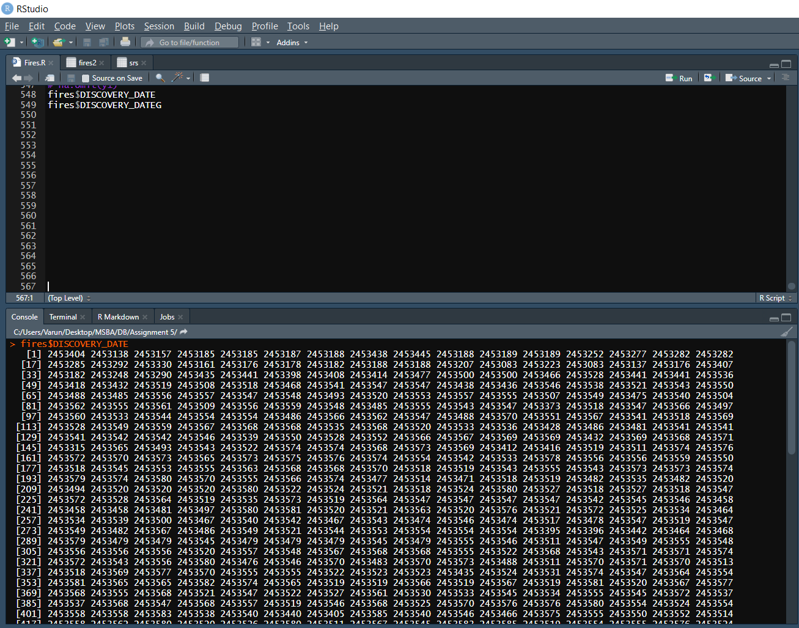

**After conversion:**

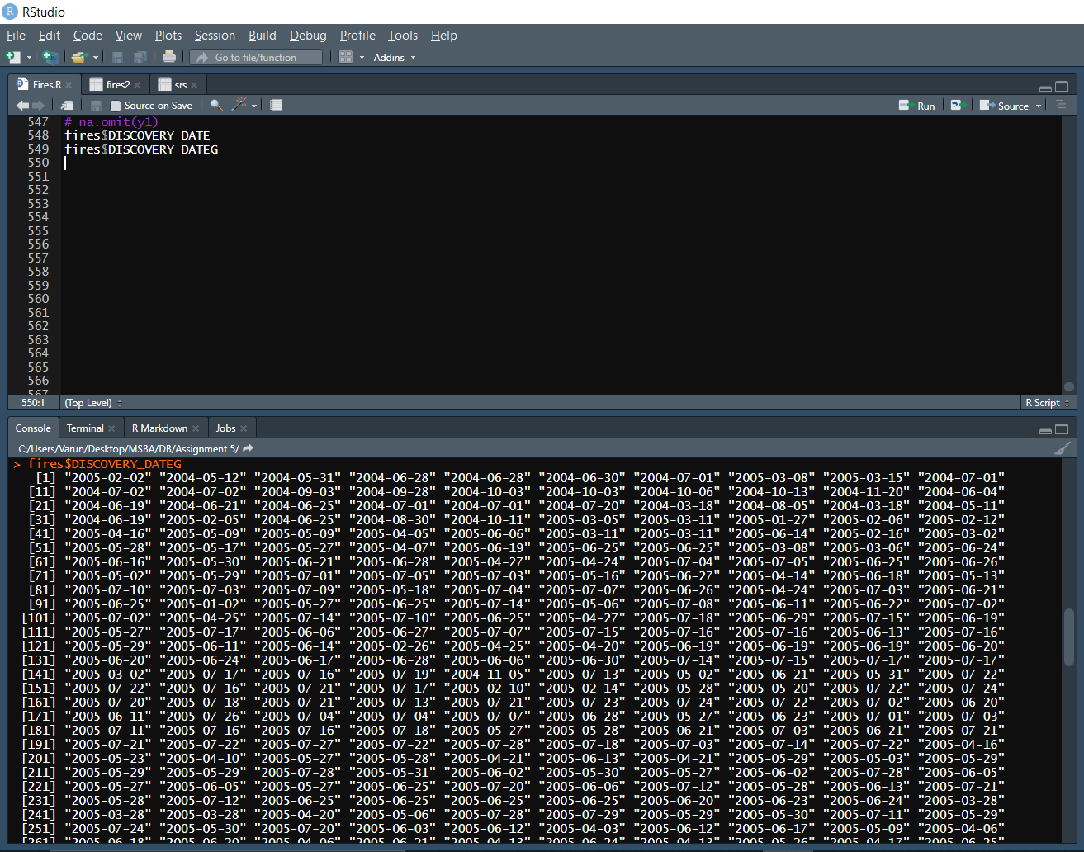

**Shapes column:**

We were unable to obtain information from the shapes column. This column contains BLOB values.

**Inconsistency between values present in** **nwcgunitid column in fires table and** **UNITID in nwcgunitidactive table:**

The following values were present in the nwcgunitid column in fires table and not in UNITID in nwcgunitidactive table

|  |
| --- |
| USVTSFM |
| USPRIITF |
| USOHSFM |
| USNDSFM |
| USMOSFM |
| USMASFM |
| USKSSFM |
| USKSKSX |
| USKSJA409 |
| USINSFM |
| USILSFM |
| USIASFM |
| USHINPS |
| USHIHIS |
| USHICNTY |
| USDESFM |
| USCODDQ |

Loading rows containing these values will cause the following problem

***Error Code: 1452. Cannot add or update a child row: a foreign key constraint fails***

This has affected 34757 rows.

The workaround to load the data into the database is to set the FOREIGN_KEY_CHECKS variable to 0 and setting it back to 1 after inserting.

**Loading data:**

The following code was run in R to load the entire dataset into MySQL

**mydb = dbConnect(MySQL(), user='root', password='root', dbname='uswildfires', host='localhost')**

**dbWriteTable(mydb, name='fires_dump', value=fires1, overwrite=TRUE)**



The dbWriteTable returns **TRUE**, meaning all the rows were inserted successfully

**Verifying in MySQL**

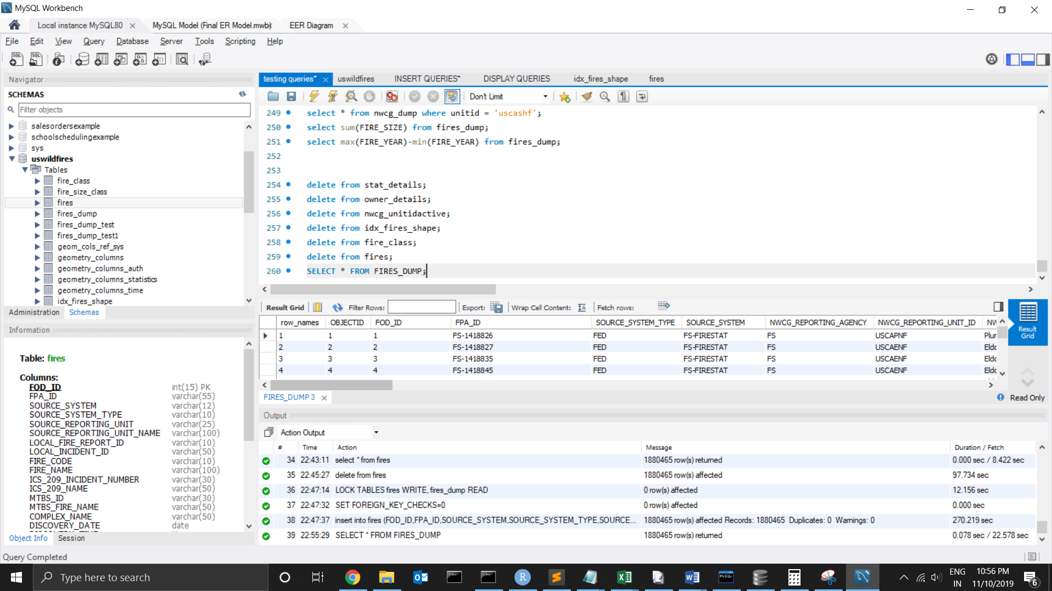

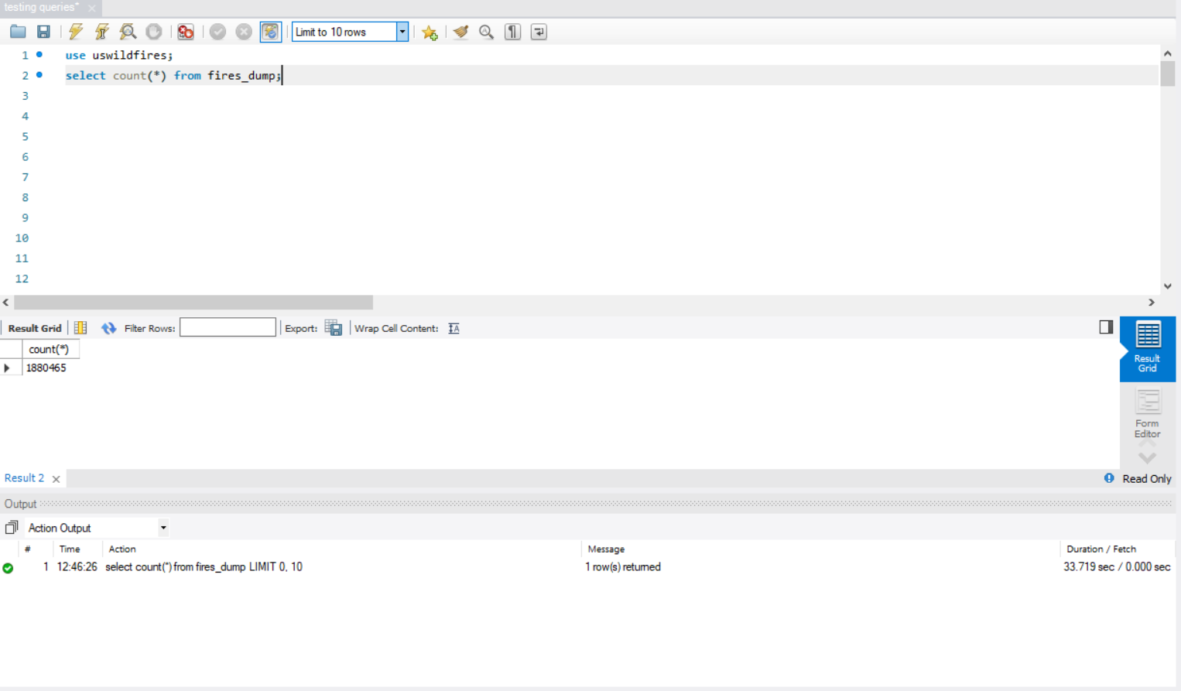

**Column Lengths:**

The following R code was used to determine the column lengths for the tables fires and nwcg

***fires_col_len <- lapply(fires, function(x) max(nchar(x,type = "chars", allowNA = FALSE, keepNA = FALSE)))***

***nwcg_col_len <- lapply(nwcg, function(x) max(nchar(x,type = "chars", allowNA = FALSE, keepNA = FALSE)))***

***ifs_col_len <- lapply(ifs, function(x) max(nchar(x,type = "chars", allowNA = FALSE, keepNA = FALSE)))***

|  |  |
| --- | --- |
| **FIRES** | |
| **Column** | **Length** |
| OBJECTID | 7 |
| FOD_ID | 9 |
| FPA_ID | 49 |
| SOURCE_SYSTEM_TYPE | 9 |
| SOURCE_SYSTEM | 11 |
| NWCG_REPORTING_AGENCY | 6 |
| NWCG_REPORTING_UNIT_ID | 9 |
| NWCG_REPORTING_UNIT_NAME | 79 |
| SOURCE_REPORTING_UNIT | 21 |
| SOURCE_REPORTING_UNIT_NAME | 74 |
| LOCAL_FIRE_REPORT_ID | 6 |
| LOCAL_INCIDENT_ID | 28 |
| FIRE_CODE | 6 |
| FIRE_NAME | 70 |
| ICS_209_INCIDENT_NUMBER | 19 |
| ICS_209_NAME | 37 |
| MTBS_ID | 29 |
| MTBS_FIRE_NAME | 49 |
| COMPLEX_NAME | 43 |
| FIRE_YEAR | 4 |
| DISCOVERY_DATE | 9 |
| DISCOVERY_DOY | 3 |
| DISCOVERY_TIME | 4 |
| STAT_CAUSE_CODE | 2 |
| STAT_CAUSE_DESCR | 17 |
| CONT_DATE | 9 |
| CONT_DOY | 3 |
| CONT_TIME | 4 |
| FIRE_SIZE | 9 |
| FIRE_SIZE_CLASS | 1 |
| LATITUDE | 11 |
| LONGITUDE | 13 |
| OWNER_CODE | 2 |
| OWNER_DESCR | 21 |
| STATE | 2 |
| COUNTY | 50 |
| FIPS_CODE | 3 |
| FIPS_NAME | 31 |
| Shape | 369 |

|  |  |
| --- | --- |
| **NWCG** | |
| **Column** | **Length** |
| OBJECTID | 4 |
| UnitId | 8 |
| GeographicArea | 2 |
| Gacc | 8 |
| WildlandRole | 28 |
| UnitType | 49 |
| Department | 5 |
| Agency | 5 |
| Parent | NA |
| Country | 2 |
| State | 2 |
| Code | 4 |
| Name | 90 |

|  |  |
| --- | --- |
| **idx_fires_shape** | |
| **Column** | **Length** |
| pkid | 7 |
| xmin | 17 |
| xmax | 17 |
| ymin | 16 |
| ymax | 16 |

**Data Loading:**

**TRANSLATION:** insert into stat_details table into the following columns Stat_Cause_Code, Stat_Cause_Descr the distinct values from the columns STAT_CAUSE_CODE, STAT_CAUSE_DESCR table

**CLEAN UP:**

**QUERY:**

-- inserting stat_details table

SET @@AUTOCOMMIT=0;

LOCK TABLES stat_details WRITE, fires_dump READ;

insert into stat_details

(Stat_Cause_Code, Stat_Cause_Descr)

select distinct STAT_CAUSE_CODE, STAT_CAUSE_DESCR from fires_dump;

-- select * from fires_dump;

UNLOCK TABLES;

**SCREENSHOT:**

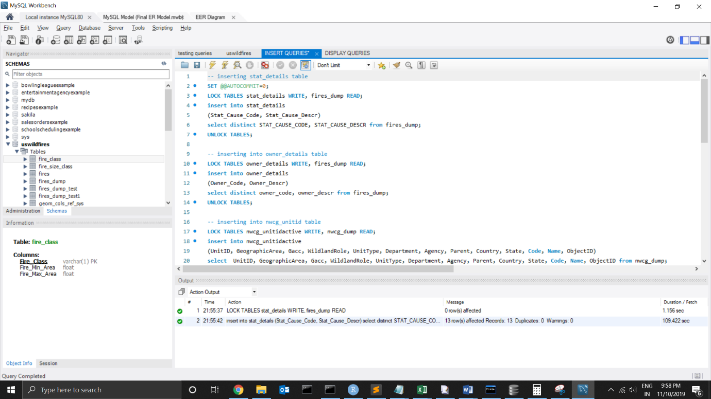

**TRANSLATION:** insert into owner_details table into the following columns Owner_Code, Owner_Descr the distinct values of owner_code, owner_descr columns from fires_dump

**CLEAN UP:**

**QUERY:**

LOCK TABLES owner_details WRITE, fires_dump READ;

insert into owner_details

(Owner_Code, Owner_Descr)

select distinct owner_code, owner_descr from fires_dump;

UNLOCK TABLES;

**SCREENSHOT:**

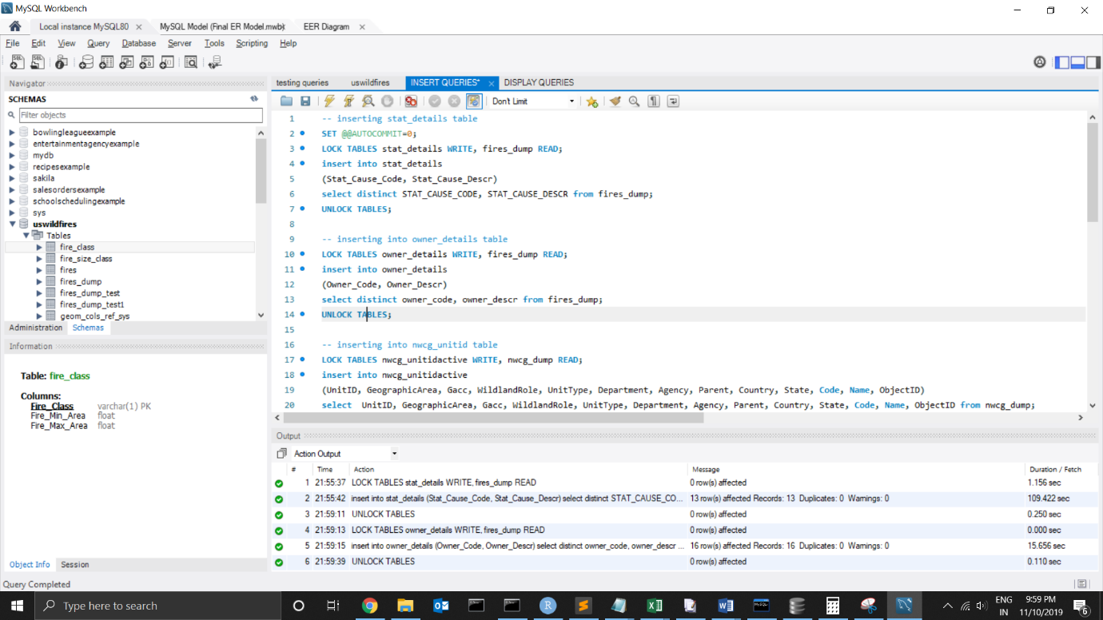

**TRANSLATION:** insert into nwcg_unitidactive table into the following columns UnitID, GeographicArea, Gacc, WildlandRole, UnitType, Department, Agency, Parent, Country, State, Code, Name, ObjectID the values from the columns of UnitID, GeographicArea, Gacc, WildlandRole, UnitType, Department, Agency, Parent, Country, State, Code, Name, ObjectID from nwcg_dump table

**CLEAN UP:**

**QUERY:**

LOCK TABLES nwcg_unitidactive WRITE, nwcg_dump READ;

insert into nwcg_unitidactive

(UnitID, GeographicArea, Gacc, WildlandRole, UnitType, Department, Agency, Parent, Country, State, Code, Name, ObjectID)

select UnitID, GeographicArea, Gacc, WildlandRole, UnitType, Department, Agency, Parent, Country, State, Code, Name, ObjectID from nwcg_dump;

UNLOCK TABLES;

**SCREENSHOT:**

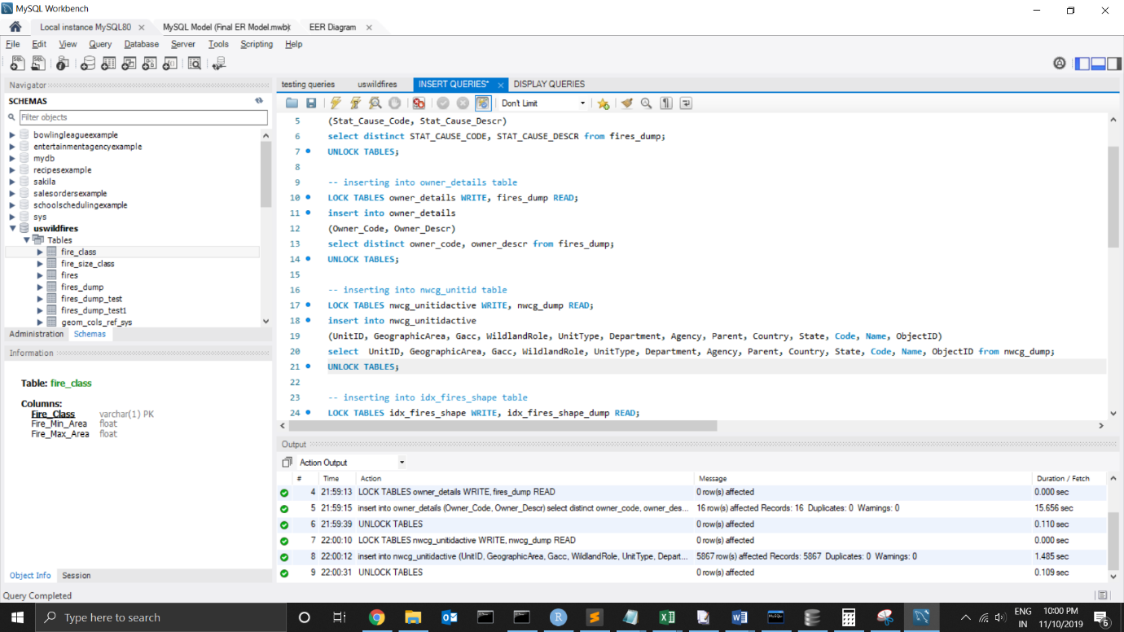

**TRANSLATION**: insert into idx_fires_shape table into the following columns pkid, xmin, xmax, ymin, ymax the values of pkid, xmin, xmax, ymin, ymax from idx_fires_shape_dump

**CLEAN UP:**

**QUERY:**

LOCK TABLES idx_fires_shape WRITE, idx_fires_shape_dump READ;

insert into idx_fires_shape

(pkid, xmin, xmax, ymin, ymax)

select pkid, xmin, xmax, ymin, ymax from idx_fires_shape_dump;

UNLOCK TABLES;

**SCREENSHOT:**

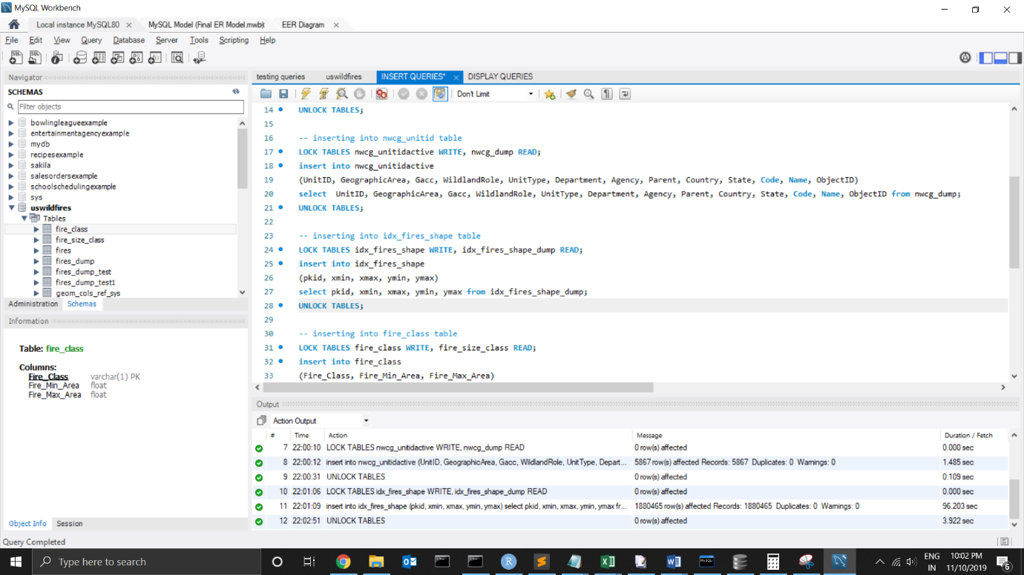

**TRANSLATION:** insert into fire_class table into the following columns Fire_Class, Fire_Min_Area, Fire_Max_Area the values of FIRE_SIZE_CLASS, MIN, MAX from fire_size_class

**CLEAN UP:**

**QUERY:**

LOCK TABLES fire_class WRITE, fire_size_class READ;

insert into fire_class

(Fire_Class, Fire_Min_Area, Fire_Max_Area)

select FIRE_SIZE_CLASS, MIN, MAX from fire_size_class;

UNLOCK TABLES;

**SCREENSHOT:**

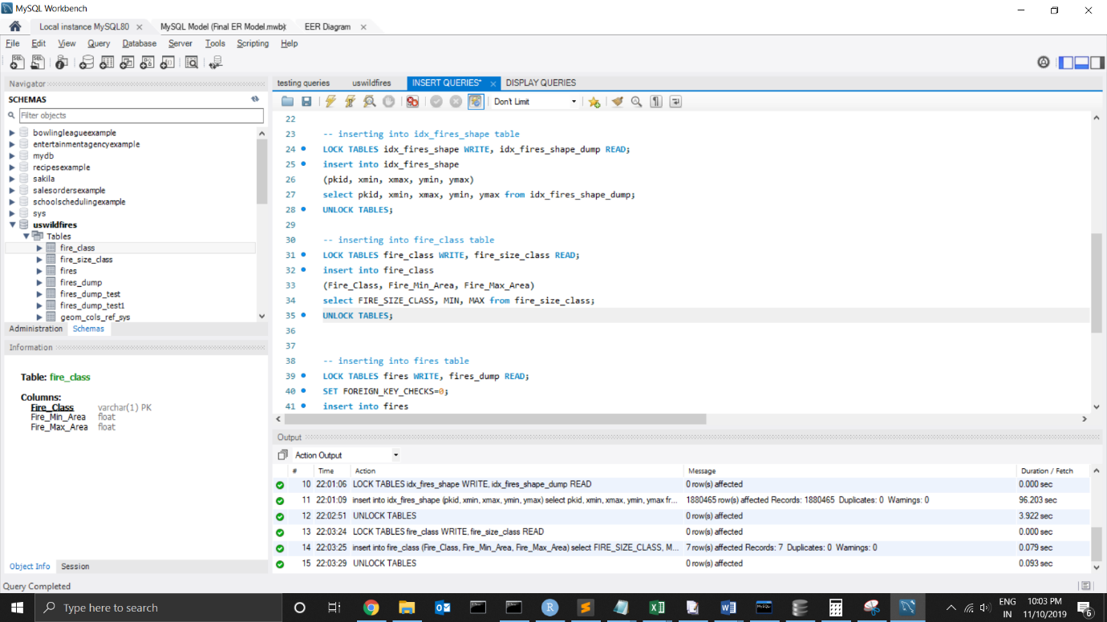

**TRANSLATION:** insert into fires table into the following columns OBJECTID,FOD_ID,FPA_ID,SOURCE_SYSTEM,SOURCE_SYSTEM_TYPE,SOURCE_REPORTING_UNIT,SOURCE_REPORTING_UNIT_NAME, LOCAL_FIRE_REPORT_ID,

LOCAL_INCIDENT_ID,FIRE_CODE, FIRE_NAME,ICS_209_INCIDENT_NUMBER,ICS_209_NAME,MTBS_ID,MTBS_FIRE_NAME,COMPLEX_NAME,

DISCOVERY_DATE,DISCOVERY_TIME,CONT_DATE,CONT_TIME,FIRE_SIZE,LATITUDE,LONGITUDE,STATE,

COUNTY,FIPS_CODE,FIPS_NAME,Stat_Details_Stat_Cause_Code ,Owner_Details_Owner_Code,NWCG_UnitIDActive_UnitID

,idx_fires_shape_pkid the values of OBJECTID,FOD_ID,FPA_ID,SOURCE_SYSTEM,SOURCE_SYSTEM_TYPE,SOURCE_REPORTING_UNIT,SOURCE_REPORTING_UNIT_NAME, LOCAL_FIRE_REPORT_ID,

LOCAL_INCIDENT_ID,FIRE_CODE, FIRE_NAME,ICS_209_INCIDENT_NUMBER,ICS_209_NAME,MTBS_ID,MTBS_FIRE_NAME,COMPLEX_NAME,

DISCOVERY_DATE,DISCOVERY_TIME,CONT_DATE,CONT_TIME,FIRE_SIZE,LATITUDE,LONGITUDE,STATE,

COUNTY,FIPS_CODE,FIPS_NAME,Stat_Cause_Code ,Owner_Code,NWCG_REPORTING_UNIT_ID,

OBJECTID FROM FIRES_DUMP

**CLEAN UP:**

**QUERY:**

LOCK TABLES fires WRITE, fires_dump READ;

SET FOREIGN_KEY_CHECKS=0;

insert into fires

(FOD_ID,FPA_ID,SOURCE_SYSTEM,SOURCE_SYSTEM_TYPE,SOURCE_REPORTING_UNIT,SOURCE_REPORTING_UNIT_NAME, LOCAL_FIRE_REPORT_ID,

LOCAL_INCIDENT_ID,FIRE_CODE, FIRE_NAME,ICS_209_INCIDENT_NUMBER,ICS_209_NAME,MTBS_ID,MTBS_FIRE_NAME,COMPLEX_NAME,

DISCOVERY_DATE,DISCOVERY_TIME,CONT_DATE,CONT_TIME,FIRE_SIZE,LATITUDE,LONGITUDE,STATE,

COUNTY,FIPS_CODE,FIPS_NAME,Stat_Details_Stat_Cause_Code ,Owner_Details_Owner_Code,NWCG_UnitIDActive_UnitID

,idx_fires_shape_pkid)

select FOD_ID,FPA_ID,SOURCE_SYSTEM,SOURCE_SYSTEM_TYPE,SOURCE_REPORTING_UNIT,SOURCE_REPORTING_UNIT_NAME, LOCAL_FIRE_REPORT_ID,

LOCAL_INCIDENT_ID,FIRE_CODE, FIRE_NAME,ICS_209_INCIDENT_NUMBER,ICS_209_NAME,MTBS_ID,MTBS_FIRE_NAME,COMPLEX_NAME,

DISCOVERY_DATE,DISCOVERY_TIME,CONT_DATE,CONT_TIME,FIRE_SIZE,LATITUDE,LONGITUDE,STATE,

COUNTY,FIPS_CODE,FIPS_NAME,Stat_Cause_Code ,Owner_Code,NWCG_REPORTING_UNIT_ID,

OBJECTID FROM FIRES_DUMP;

SET FOREIGN_KEY_CHECKS=1;

UNLOCK TABLES;

**SCREENSHOT:**

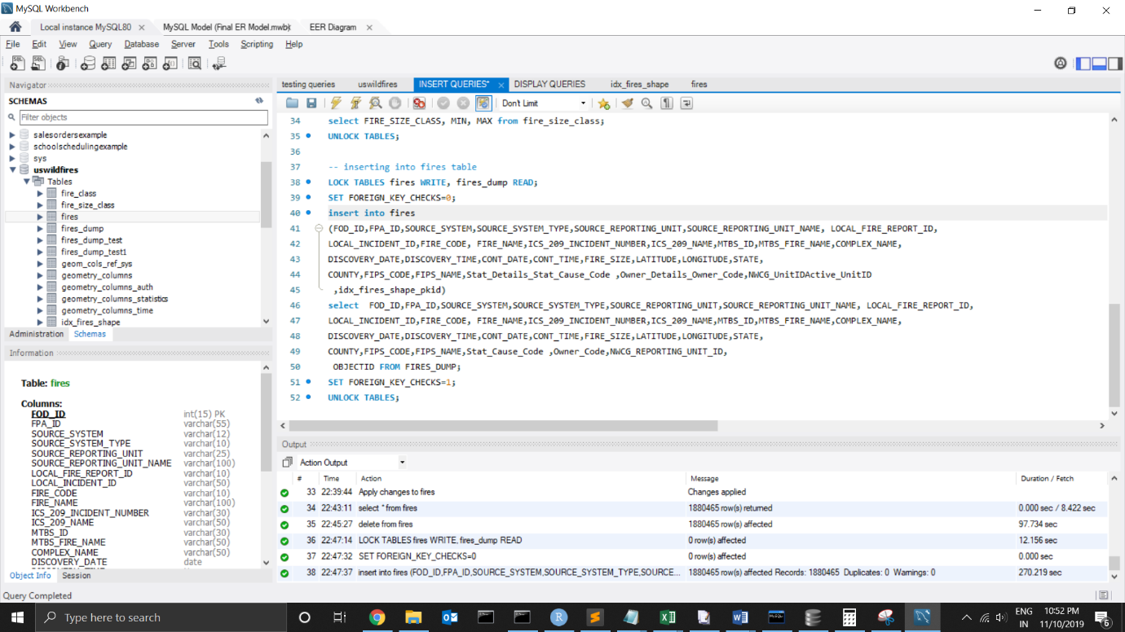

**Loaded Data:**

**Stat_details:**

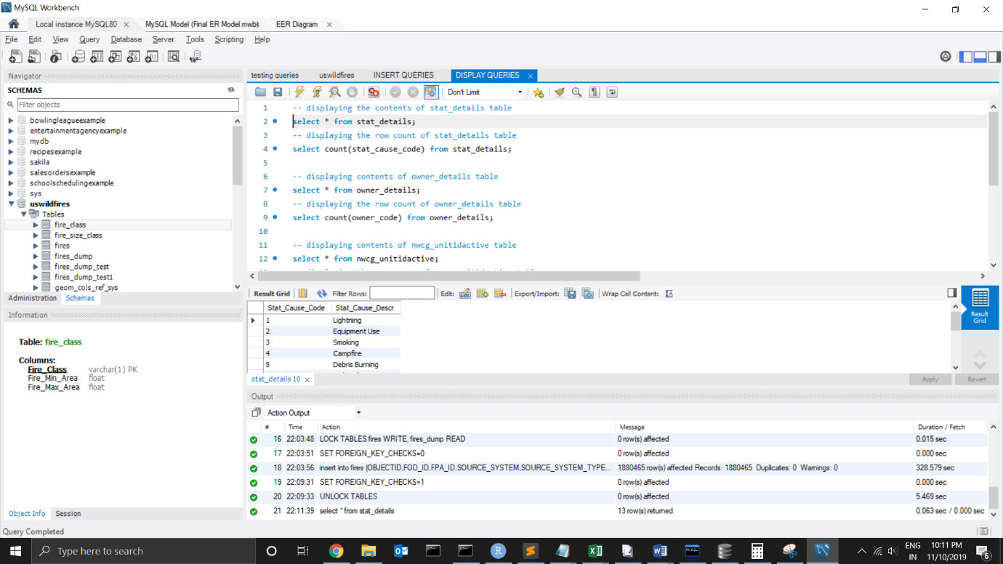

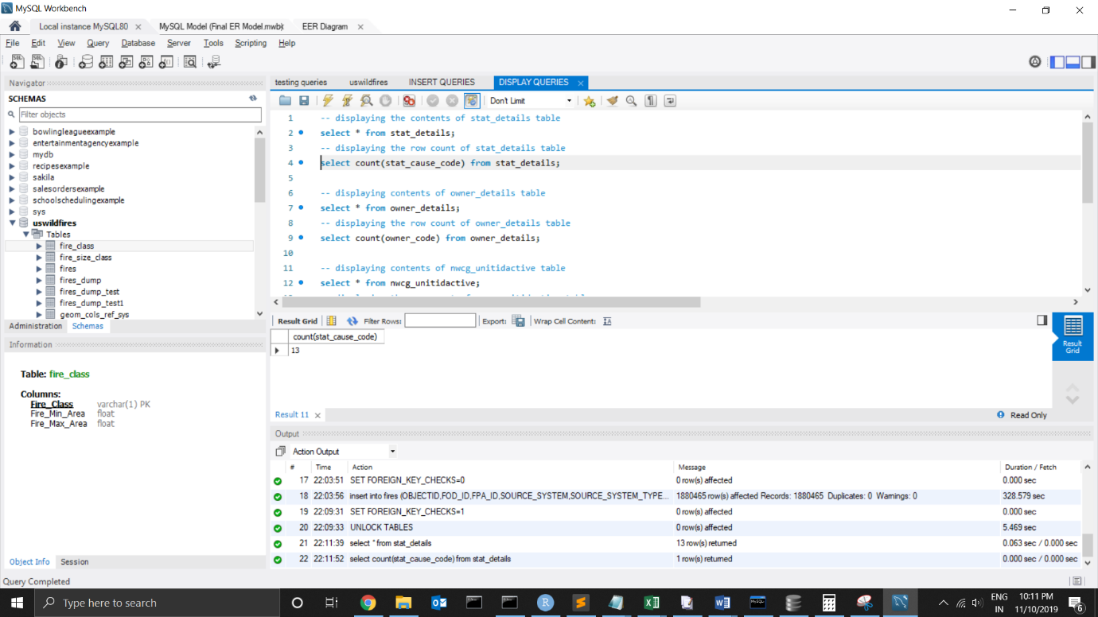

**Owner_details:**

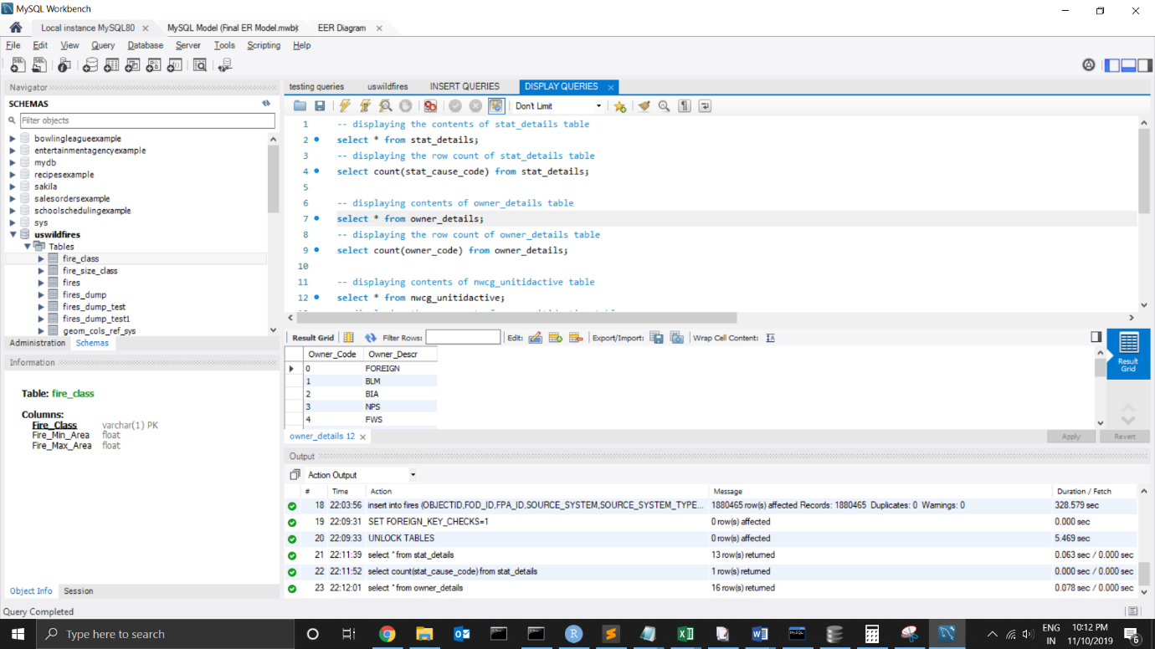

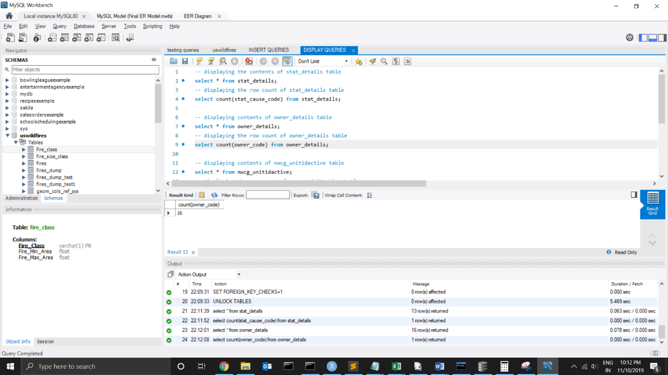

**NWCG_UnitidActive:**

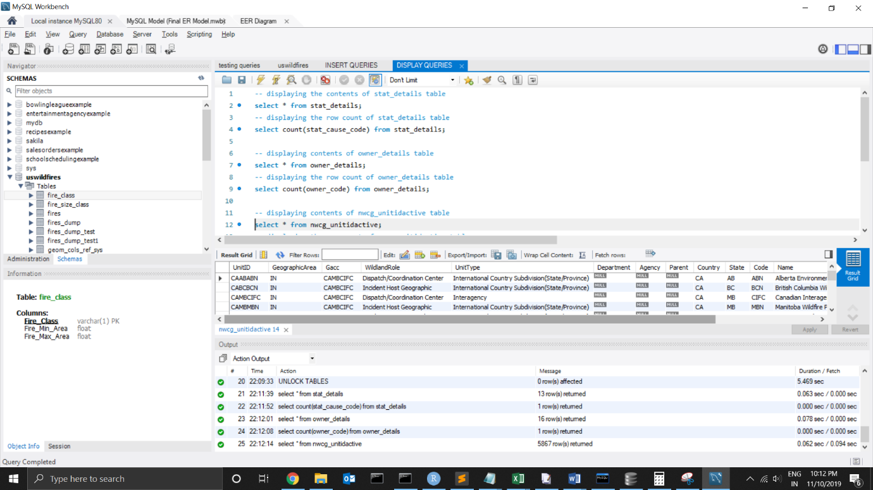

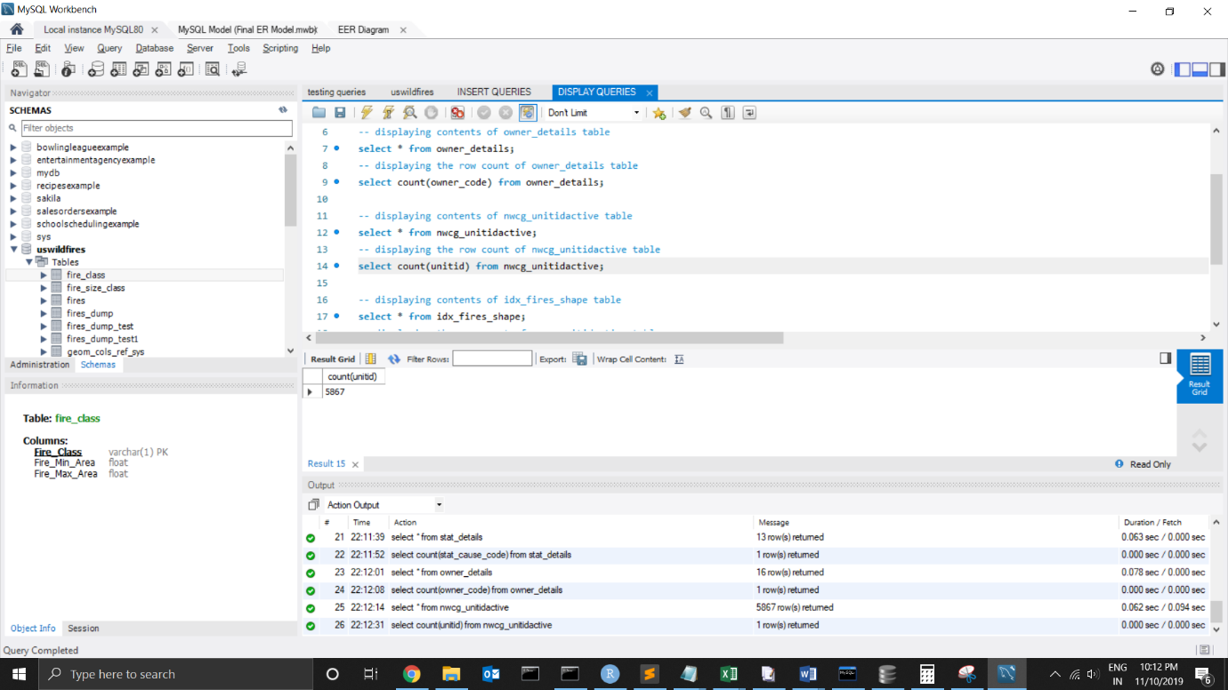

**IDX_fires_shape:**

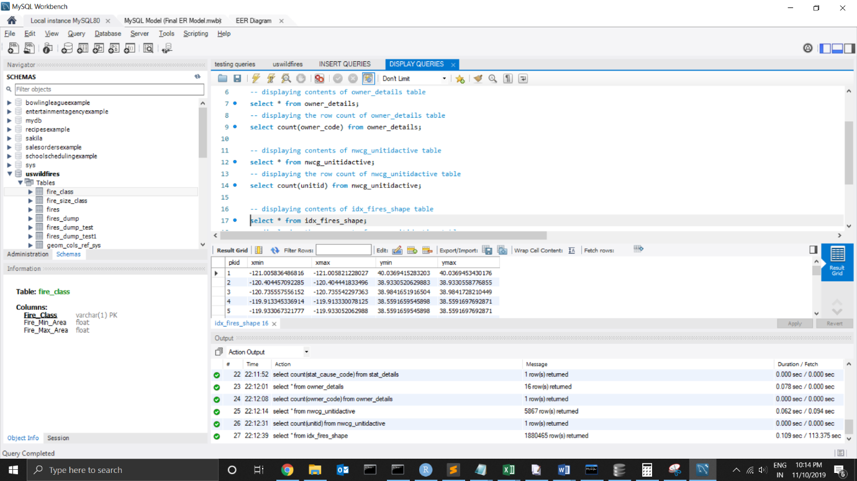

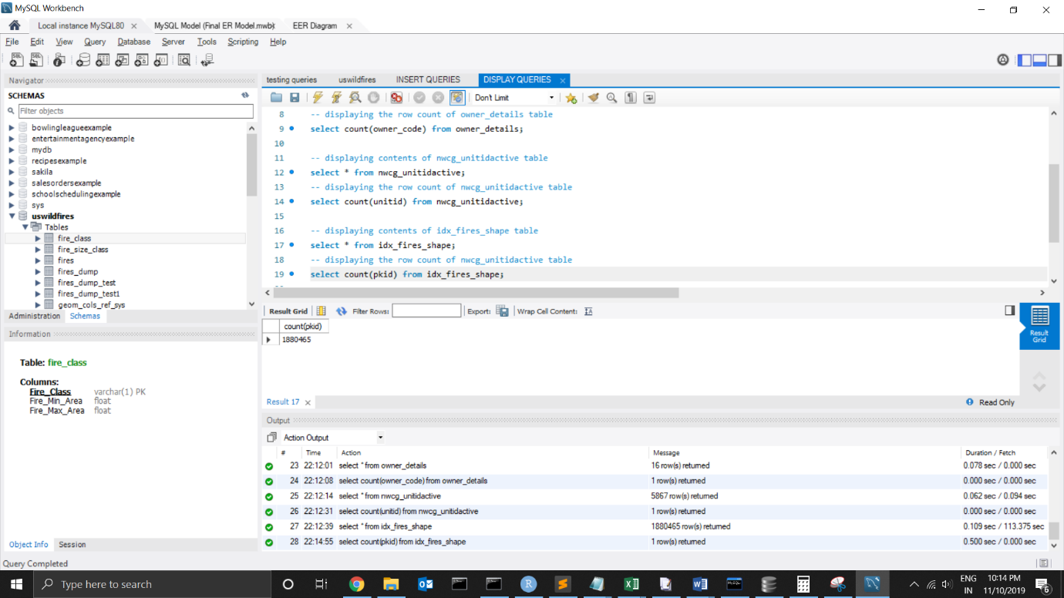

**Fires:**

